Internet of Things in Smart Agriculture Farming

|  |  |  |  |
| --- | --- | --- | --- |
| Sarthak Agrawal  Information Technology and Management  Illinois Institute of Technology  Chicago, IL, USA  sagrawal4@hawk.iit.edu | Shivani Agrawal  Information Technology and Management  Illinois Institute of Technology  Chicago, IL, USA  sagrawal3@hawk.iit.edu | Divya Rathnakar Poojari  Information Technology and Management  Illinois Institute of Technology  Chicago, IL, USA  [dpoojari@hawk.iit.edu](mailto:dpoojari@hawk.iit.edu) | Megha Shrivastava  Information Technology and Management  Illinois Institute of Technology  Chicago, IL, USA  mshrivastava1@hawk.iit.edu |

ABSTRACT- Sarthak Agrawal

Smart farming must meet production efficiency, ecological tolerance, effective technologies and environment sustainability, cultural diversity and fulfillment of basic needs in scope of development plans. It emphasizes on developing techniques that primarily improved the conventional farming process. The Farm Management Information Systems (FMISs), which facilitates integration of information acquisition and storage, monitoring, scheduling, decision making, reporting and management of farm operations, are one of the key elements for smart farming which is now adopting Internet Of Things (IoT) to further improve the business objectives. Smart farming exhibits the convergence of biotechnology with space and informatics that would indeed lead to a vision of groundbreaking development route in farming, with the context of WTO rules and environment crisis that threaten to reduce productivity. The financial gains of smart farming technology are restricted by the small size of fields and farms in most parts of India while issues like the increasing population, climate, food security and animal welfare have led to significant political attention given to the potential advantages of adopting smart farming. IoT devices usually have specific technical and reliability criteria in agriculture, including the collection of communication protocols, the data processing capacity, the level of security, the security and time efficiency. Implementation of smart farming in India is not unimaginable. With extensive research of its benefits and challenges, it would be possible to bring smart farming into reality in a developing country like India.

**Keywords**: Smart Farming Technology, Information and Communication Technology (ICT), Internet of Things (IoT), Precision Farming

1. INTRODUCTION- Divya Rathnakar Poojari

This is a smart age where even our phones are often more knowledgeable than we are. Primitive technologies, ancient practices and distressed farmers that are insecure about the future of their farming as well as themselves has been a spectacle in majority of areas excluding few developed regions in India. They are as adamantly dependent on rain as their faith in God, even in 21st century. Bound in the brutal citadel of debt, marginal income and increasing expenditure, the farmers might have never heard of a potential savior-Smart Farming Technologies. As far as technology use and its applicability are concerned, there has been a considerable negligence towards farming, particularly in a developing country like India where acceptance to technology is limited and there is a lack of technical expertise for the use of already existing technology. The improving accessibility to low-cost IoT devices and affordable solutions for smart farming have effectively alleviated the complexities related with implementation of Big Data analytics in smart farming.

Around 70% of rural household and 8% of urban household still primarily rely on agriculture for employment and since 3/4th of the population lives in rural areas, most households are mainly dependent on this sector. India has experienced a series of successful agricultural revolutions – beginning from the Green Revolution in wheat and rice in 1960’s and 1970’s, the White Revolution in milk to the Yellow Revolution in oilseeds in 1980’s making India self-sufficient in agriculture, although the share of agriculture in the GDP was adversely affected by the industrialization of the Indian economy.[23] But the application of agricultural inputs at a standard rate did not yield desirable results due to lack of concern to in-field variations in soil fertility and crop conditions. The monitoring of these in-field variations in the soil quality and the crop health, thus minimizing the environmental impact is the essence of Smart Farming. Geographically, India is divided into different agro-climatic zones and the requirement of data for implementing smart farming is different for each of these zones.

It can be said that IoT in agriculture is simply a merge of IT, telecommunications and sensor technologies applied in the field of farming. Some of the best examples of IoT application in agriculture is development of smart irrigation and facilitating real time monitoring of soil vitals and crop health. In short, the main aim of combining farming with technology is to empower the farmers by enhancing their crop production irrespective of their cultural and educational backgrounds. This campaign can prove to be quite a revolution for an agro-based economy like India.

Smart farming is this century’s most important breakthrough in farm management centered on the use of Information and Communication Technologies. In order to maximize productivity, efficiency and the conservation of land resources, an Information and Technology driven farm management system recognizes, analyzes, and controls variation in fields through application of smart farming practices in the proper place, time and manner. One of the key elements of Smart Farming is the development of Farm Management Information Systems. The IoT aids in capturing and merging smart and digital data. It also helps in incorporating sensor data from various machines, livestock, other farms and greenhouses as well as other unmanned air and land vehicles. Increased precision use of farming activities such as crop monitoring, pest management, irrigation, etc. and further encouragement in decision-making and planning in the agricultural sector renders an even more effective and efficient farming system.

It is important to build the appropriate IoT architecture for IoT based farming management information system representing the overall gross framework structure. The IoT based FMIS have functional requirements such as crop type, sensor type and data processing capabilities as well as varying performance criteria of multiple software implementations including security level, safety level, time efficiency, designing and operating costs.

1. PROBLEM DESCRIPTION- Divya Rathnakar Poojari

Gross value in the Indian economy from the agricultural sector (farming, forestry and fishing) is approximately $274 billion for the financial year 2017-18 raising at a compound annual growth rate of 2.8% in the period from 2011-12 onwards. Significantly, GDP (16%) and employment (49%) are compensated by agriculture as stated by 2017-18 India Economic Survey.[24] Thus, it is evident that poor agricultural performance can hold the economy back by causing inflation, distress and political and social turmoil. The Agricultural policy of India has noticed some drastic shift of focus from agricultural production to increase in the farmer’s income. In February 2016, the Prime Minister of India issued a call for doubling the farmers’ revenue by 2022. [24] This call was brought into action in the Union budget of 2016-17 where the Finance Minister clarified its motto of thinking beyond ‘food security’ and providing or Indian farmers a sense of ‘income security’ thus, re-orienting its activities in the farm and non-farm sectors. Hence, any action taken in the field of agriculture must have the potential of increasing the farmers’ income. A Columbia University is working on a project titled ‘A New Indian Model of ICT-led Growth and Development’ in collaboration with The Energy and Research Institute (TERI) to explore the potential of use of Information and Communication Technologies in the agriculture sector of India. We believe that India's new ICT-led growth model along with a solid strategy and the required modified ICT tools, can boost India's growth, which is now typified by high poverty and a low social and economic growth.

Research suggests that the two most critical hurdle in the implementation of smart farming are education and monetary. Where lack of expertise, funding, competent research and technical personnel contribute to the educational challenges, the initiation costs of smart farming contribute to the monetary challenges. Majority of farmers are illiterate or have completed primary education and are therefore hesitant to use digital devices fearing its technicality and complexity. So, they find it difficult to complete transactions or carrying out activities as simple as recognizing the icons on the device to be used. This gap between their expertise and the already available design is a key obstacle in adopting smart farming. On one hand, the farmers need to be technically sound in order to fully use the benefits offered by smart farming technologies whereas on the other hand, the agri-tech companies developing such devices should understand the academic capability of the users and design simpler easy to use devices.

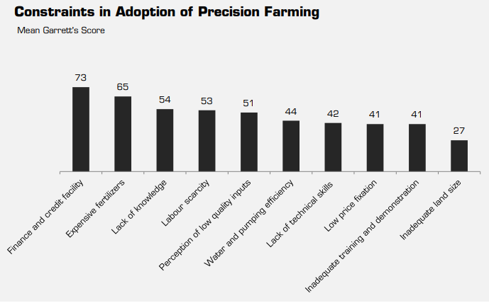

**Fig 2.1: Constraints in Adoption of Precision Farming [25]**

While the overall agricultural production in India has grown over the years, in 1951, the number of farmers dropped from 71.9% to 45.1% in 2011 and it is estimated to drop to 25.7% by 2050 by The Economic Survey 2018.[24] Farming families are rapidly losing the next generation farmers infested by low per capita productivity and high cultivation costs to poor soil management and choose a non-farming and better paid profession. India can never be as mature as it is today for adapting smarter technologies. The vast acres of land is at the brink of a digital revolution. Hence, it is high time we start to actively implement smart farming technologies and ascend digital technology support to our farmers.

1. AREAS OF IMPROVEMENT-Shivani Agrawal

Since majority of farmers, approximately 86%, are poor and marginal with fragmented land ownerships, vulnerabilities like high price instability, unpredictable climate changes and arrearage make them even more helpless and open to risks. The Indian Government’s last two funding schemes were dedicated to agriculture. Due to this, there were more resources allocated to agriculture and several programs were underway to improve irrigated areas, improve soil health and encourage agro-processing and increase the potential for overcoming production risks among many others. Nonetheless, agricultural unrest seems to be growing seamlessly amongst the states. India needs a four-point program which deals with the farming challenges and merges various efforts and programs within a single framework.

1. **Increasing incomes:** Transition of agriculture in India is very sluggish. Consequently, it generates the agricultural income slowly. It was Prime Minister Narendra Modi who welcomed the idea of the paradigm shift to doubling the peasant’s income by 2022. Agricultural diversification will need to facilitate quality products and the growth of supply chains, through the connections between production and marketing centers, and eventually, to establish strategies for ensuring reasonable support rates in case of failure. It will need several things: an ambitious drive to upgrade technology by improving the seed industry, and the information dissemination; diversification of the agricultural sector in favor of high value commodity and growth of value chains by connecting the supply with the marketing centers. Growth can focus on the integration of growers and advertisers by encouraging contract agriculture, cluster growing, farmer associations and self-help groups.
2. **Generating Employment Opportunities:** More than 40% farmers would choose to leave farming as the profession, as stated by the Situation Assessment of India.[26] Agriculture is getting highly competitive and thus provides lesser employment opportunities. This lack of employment in rural areas has led to relocation of the youth to urban areas for better professions and increased wages. Currently, more than 70% of India’s youth lives in rural areas. It is necessary to tap their power and passion in a specific way that would help satisfying their ambition as well as transform the Indian economy with respect to agriculture. Yet, it wouldn’t be possible to accommodate the India’s youth through agriculture.
3. **Reducing risks in agriculture:** Farmers are facing increased risks day by day. The threat of production and cost also causes persistent agricultural distress. Droughts, flooding, variations in weather, and unseasonal rain and hailstorms are growing and adversely affecting farm output. There are now some production risks incurred by the National Agricultural Insurance Scheme of the Prime Minister. Although the system is good, compensation does not cover the risk of declining prices and is inadequate. In order to cover production and price hazards, the government must consider launching a "Prime Minister's Climate Resilience Scheme." Such a strategy might integrate climate-smart agriculture with value added environment advice and successful agricultural insurance application, thus guaranteeing minimum aid rates.
4. **Developing agri-infrastructure:** Agricultural infrastructure — including growers, cold storage, warehouses and field processing — has not grown with increasing agricultural production in a proportional pace. The distribution chains for agrifood goods are in the control of an unstructured, fractured and wasteful industry, without appropriate agri-infrastructure. Because of a lack of commercial viability in building the agri-infrastructure, a better-organized private sector is emergent. In designing agri-infrastructures for significant economic and social benefits the position of public-private collaborations is paramount. In the agri-infrastructure market, the State will establish a commission for designing strategies and recommendations for public-private partnerships.
5. SIX ELEMENTS OF SMART FARMING

Data is the essence of IoT. In order to enhance the current agricultural system, IoT devices mounted in a farm will gather and process data in a repeated cycle which helps farmers to react quickly to ad-hoc concerns and be prepared to face any sudden change in the environmental conditions.

Observation: sensors record the data from livestock, crops, soil or climate

Diagnosis: The data is fed to a specific software with a predefined collection of judgements or rules which helps to ascertain the condition of the monitored object, its needs, diseases or deficiencies.

Decisions: After the diagnosis, certain decisions are suggested which determines the actions to be taken.

Implementation: The decision taken is then implemented with the coordination of machines and software.

The major objective of introducing IoT in Smart farming is to make agriculture data driven and data enabled with the integration of smart machines and sensors. Armed with the correct equipment, soon the farmers would be able to make strategic decisions for the entire field or a even a single crop without the need to even step into the field. The six elements which play a major role in Smart Farming are: Sensor Technology, Software Applications, Communication systems, Telematics and positioning technologies, Gadware devices and Data Analytics. Each of the element is described in detail in the upcoming sections.

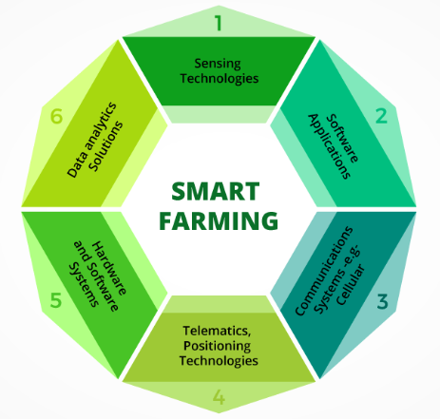

**Fig 3.1: 6 Elements of Smart Farming [19]**

3.1 Sensor Technology – Megha Shrivastava

A range of sensing technologies can be used in smart farming which are adaptable to all the changes that occur in the environment and provides the farmers with all the information that could prove useful in monitoring as well as optimizing the crops. Such sensors which help in the smart farming techniques are listed below:

**Location Sensor:** These sensors use GPS satellite signals to determine latitude, longitude and altitude, and provide accurate positions as precise positioning is the essence of precision agriculture A minimum of three satellites are needed to calibrate a location.

**Optical Sensor:** The optical sensors are used to determine the organic matter and the moisture content present in the soil. These two are generally used in the process of smart farming. The optical sensors can also be helpful as they can measure different light reflectance frequencies of distorted light wavelengths.

**Electrochemical Sensor:** In the smart farming the soil nutrient as well as the pH are the two basic information required. These components are detected by the ions which are present in the soil using sensor electrodes that helps in mapping and processing chemical data.

**Mechanical Sensor:** These sensors determine the soil compaction with the help of probe. They can also be used on tractors to foresee pulling requirements for ground engaging equipment.

Also, there are various locations where the sensors are placed called as the farming weather stations. These stations contain the combined sensors which provides the information about temperature, the climate condition which includes the wind speed and its direction. The data collected from these sensors is arranged properly and is then sent at regular intervals, which helps in the process of smart farming. The sensing technologies have the advantage of minimizing the effects which are caused due to the environmental conditions. The smart technologies use the internet of things and provides the farmers with the techniques like seeding, fertilizing etc. which are the important processes of smart farming. Generally, this information is collected by various sensors. The smart farming has reduced the efforts of the farmers and has adapted to all the changes in the environment. Though the smart farming techniques have already been implemented in larger farmer areas around the globe, this plan of smart farming will only be effective if these techniques are utilized in smaller areas as well. The machines used in the smart farming at a smaller scale would be of reduced size, but it will help reduce pollution and labor work.

3.2 Software Application - Megha Shrivastava

Farm management software is used to automate and manage farm operations and production activities like data recording, record management, reporting and reviewing of farm activities and standardizing production and work schedules. There are various software applications which are used for the betterment of smart farming. Software applications may vary from farm to farm as different lands have different requirements. Few examples of software applications that can come handy are listed below:

**Granular**: Founded in the year 2014, this is one of the management software used in the farming which results in making the farm more profitable. Besides remote monitoring of all the operations, this software can also assign and schedule tasks. Also, it helps to keep their stakeholders up to date through their well-managed reporting suite.

**Conservis:** Conservis is an easy to use and the most trusted software which is used for the management of agronomic operations with more control and less uncertainty. This software was founded in 2009 and was in United States. Although farming is one of the most complicated business, but this software simplifies the task at each step with hands-on guidance and increased transparency and confidence.[4]

**Smart Farm:** The smart farm software was founded in 2010 in India. It is cloud based which generally completes the digital work of the farm and helps in decision making techniques. The smart farm technique gives the flexible farming system by using the concepts of machine learning, artificial intelligence etc.

**AgCinect:** This software was initiated by the United States in 2016. This is purely cloud based software which can be accessed by multiple users through any device. In this data is collected and is provided by the reports, finances and the analysis of the data. This software gives the details about tracking the crop and helps in all the financials and the accounting of the farming system.

**Croptracker:** This software was founded in Canada and in the year 2006.[4] This is one of the award-winning software in all the management software. This software keeps the record about the chemicals which are to be used in the farming.

**Produce Pro Software:** This software was earlier implemented by the United states in the year 1990. This software is used by more than 10 companies and can work in all the platform whether it is mac or windows.

All these applications are specialized software solutions which are used at the IOT platforms for achieving the target of the specific farming techniques.[4] By these software applications many of the problems related to smart farming can be resolved and has led to the betterment of smart farming software techniques.

3.3 Communication Systems- Divya Rathnakar Poojari

When applying IoT to the agriculture domain, Machine-to-Machine (M2M) communications are a central key, empowering ubiquitous and independent communications amongst numerous gadgets without any human interference. In this way, necessities such as productivity, versatility, low-cost equipment and low-power utilization are expected from this kind of communications. The demand for these necessities varies according to the various application scenarios, which has driven to the development of endless number of conventions, standards, communication stacks and models, each one addressing specific issues or applications.

**LPWAN Technologies**

Demand for low power communications has led to increase in the use of Low-Power Wide-Area Network (LPWAN). The LPWAN technologies can be used like some of the short-range communication technologies by positioning them between cellular networks and operating them in the license free band of the spectrum, thus, potentially covering the communication ranges similar to a cellular cell. The data rates are also like the short-range communication solutions which are adequate for many IoT solutions. Some examples are Sigfox, Long Range (LoRa) WAN, NarrowBand-IoT (NB-IoT) and LTE-M.

Sigfox is a centralized and low-throughput wireless communication system which is efficient energy-wise but provides limited capacity, smaller coverage area, insufficient bandwidth and prohibits localization.

LoRa is a Wireless Wide Area Network specification designed to minimize energy consumption and provide long range communications. It provides a reasonable bandwidth, permits RSSI-based localization and can be used as a private network. The only disadvantage of LoRa is its poor performance due to low data accuracy for wide range applications and its cost in case it is considered for each animal sensor.

NB-IOT and LTE-M, part of 3GPP Long-Term Evolution(LTE), have been developed for M2M ad IoT applications. Despite its advantages of high bandwidth provision and potentially low power consumption, it depends on a public communication infrastructure which is not available in rural areas. Moreover, the need for paying fees to the telecom operator arises thus making the exploration costs intolerable.

**Non-IP Protocols**

There are several applications that also resort to non-IP solutions like ZigBee and BLE for optimized use of resources, processes and communications.

ZigBee is based on IEEE 802.15.4 standard for the Physical and MAC layers with its higher layers defined by the ZigBee Alliance. It provides a framework for low-power wireless communication. Nonetheless, IEEE 802.15.4 poses specific limitations when considered for TDMA applications.

BLE is an upgraded version of the classic Bluetooth, allowing 10-fold higher communication ranges, lower radio power and lower latencies. In addition to its significant reduction in power consumption and increased range, the application of star and mesh topologies remains significantly limited.

**IoT Gateway**

An intermediary unit, typically known as an IoT gateway, is required to allow interaction between devices that rely on different communication technology or devices that use different application protocols. A number of standards have been developed that specify the deployment of IoT gateways to support M2M / IoT services. One of the most relevant ones is the OneM2M that provides a horizontal platform and supports secure, reliable and efficient operations of multiple IoT/M2M services, particularly those dependent on REST APIs. It also supports multiple existing application protocols like HTTP, CoAP and MQTT and communication technologies such as ZigBee, Bluetooth, WiFi and Cellular networks as well as the IMA-DM and BBF TR-069 protocols. There are other turnkey solutions differentiated by the application protocols that they support like the INTEL and the SmartM2M.

In sum, they share a common goal of creating an integrated IoT platform that supports multiple applications, protocols and standards. Despite the great advantages that a fully integrated IoT/M2M could deliver, the assets and resources it needs may be superfluous in the smart farming, where flexibility, low cost and high autonomy are the key features. It is expected that the number of gateway devices are limited. In fact, they are not regularly relocated and are usually allocated in accessible locations. Gateways can use more powerful hardware for processing and storage capacities as they are assumed to not be subjected to stringent restrictions on power, size and energy consumption.

The idea of IoT has emerged as a result of the exponentially increasing number of devices connected to the internet in almost all sectors of the society. A wide range of applications, with distinct specifications and restrictions, has resulted in a multitude of protocols, standards and communication stacks being developed, each trying to fulfil specific requirements.

**Future Scope with use of 5G**

5G has the potential to disrupt many industrial sectors including farming because the design of smart farming is depending heavily on both mobile internet and automated devices for real-time, reliable production and management. Next generation 5G can be 100 times faster than 4G making communication between services and devices much easier by carrying more data than other networks.5G has already been put in use in certain regions.

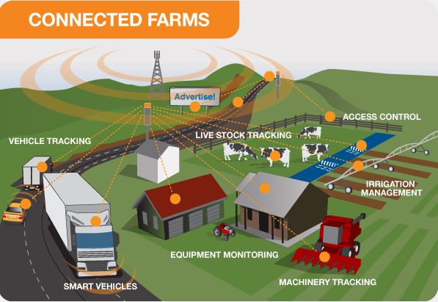

**Fig 3.5.1: Connected Farms using 5G[18]**

For example, drones using 5G are helping to improve potato production in Netherlands and 5G sensors are used to monitor water temperature and salt concentration of oyster farms in Japan. The UN Food and Agriculture Organization predicts that the planet needs to produce 70% more food in 2050 than it did in 2019 to provide for the world’s rising population. To meet these demands, the farmers would be needing new technologies that would help them produce more from less land and this is where 5G will play a major role. In 2017, a project named 5G RuralFirst became the first to successfully plant, tend and harvest a crop without a single human stepping onto the field. Another campaign in 2018 called Hands-free Hectare, announced a successful harvest. This project is further being pushed to use 5G technology which would increase its precision and efficiency. Thus, it can be said that 5G technology has started to be applied in the farming industry but in order to make a difference, 5G needs to be first deployed in rural areas.

3.4 Telematics and Positioning Technologies- Divya Rathnakar Poojari

Smart farming (SF), focused on the integration of information and communication technology into machines, equipment and sensors of farming systems, enables the generation of a large volume of data and information with the increasing introduction of automation into the process. Smart farming depends on data transfer and data consolidation in remote storage facilities so that various farm data can be compiled and interpreted for decision-making. Telematics involves precision farming solutions by automating decisions or actions at a distance. The basic concept behind precision farming is that instead of manually applying seeds and fertilizers evenly in the fields, the farms should be cautiously mapped using proper soil sensor machinery and this smart machinery would spread seeds and fertilizers evenly based on soil characteristics like humidity, nitrogen concentrations, organic matter content, etc.

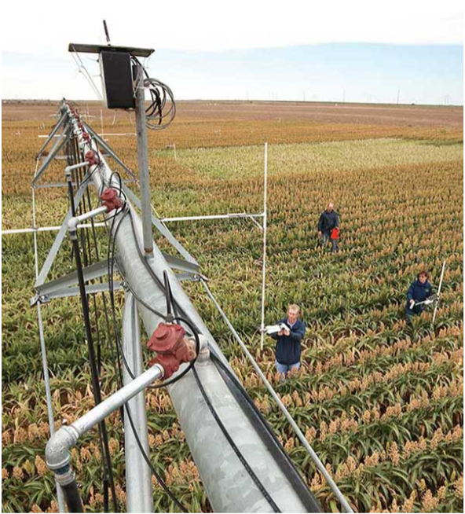

**Fig 3.4.1: Optical sensors advancing precision [20]**

**Variable Seed Application**

The machines can be physically or remotely controlled utilizing gadgets such as an Xbox controller. A smart phone is utilized to dispatch independent operation. A guidance algorithm conveys ±2 cm precision. Speeds are accurately controlled, and the programmed speed control makes secure turns. These smart machines can work day or night with amplified hours of nonstop operation. A few machines have discretionary highlights, such as remotely available cameras, remote monitoring, symptomatic frameworks and climate stations. The savings from using this smart machinery could be 15 to 19 percent on fertilizer and 6 percent on seeds mainly because the turning of the spreader at the end of the row is very precise and the seed or the fertilizer is never placed in the same spot twice. IoT and related technologies will reshape the farm’s business model as the sensors installed on GPS-equipped machinery will collect huge amount of data which is used by Big Data to create a digital platform. The farm equipment would connect to the platform through drones, satellites, robots and autonomous super-tractors for sowing, fertilizing, planting or working on a field independently throughout the day.

**Variable Rate Fertilization**

Fields can be separated into management areas where fertilizer application maps are used to indicate the amount of fertilizers needed as per circumstances. Light Detection and Ranging (LiDAR) is an optical remote sensing technology that measures distance using light. It creates a topographical map of the farms revealing the slopes and the land exposure to sun and then determines where the expensive fertilizer needs to be applied. The yield of every year is recorded, and this data is used by researchers at Agricultural Research Service to compare the records and determine the year of highest, medium and lowest yields.

**Crop Mapping**

Another application is crop mapping in orchards and vineyards to reveal vegetation growth as well as the need for trimming and servicing and fruit production variation. Optical crop sensors are used to gauge crop conditions by reflecting light at the crop leaves and measuring the amount of light reflected at the sensor. 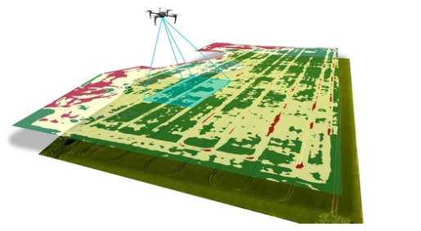

**Fig 3.4.1: Crop Mapping using Drones [17]**

It is used to develop vegetative indices to compare the health of various crops by studying the reflectance characteristics of plants and to measure canopy nitrogen status.

Farming equipment appears to be large, expensive and incredibly heavy i.e. if anything goes wrong, the vehicle won’t be able to move under its own power. This is where telematics can act as a savior where it keeps the vehicle under constant monitoring ensuring remote management and diagnostics and direct technical assistance. The leading companies working on the global agricultural precision market combine telematic data with back-office inputs to generate real-time insights into farm production and organizational productivity.

3.5 Data Analytics - Sarthak Agrawal

Smart Farming is a concept that stresses on the utilization of information and communication technologies in the farm management process. It is expected that new technologies such as the Internet of Things and cloud computing will harness this growth and implement robotics and artificial intelligence in farming. This is endorsed by the Big Data phenomenon, massive volumes of data with a wide variety that can be captured, evaluated and used to make judgments. This evaluation is intended to gain insight into the state-of-the-art of Big Data programs in Smart Farming and define the related socio-economic challenges that need to be tackled. The survey shows that the extent of Big Data applications in Smart Farming goes past primary production, affecting the whole nourishment production network.[3] Enormous information is being utilized to give prescient bits of knowledge in cultivating tasks, drive continuous operational choices, and upgrade business forms for game-changing plans of action. The stakeholder ecosystem demonstrates an interesting game involving powerful tech corporations, venture capitalists, and often small start-ups, as well as new entrants. Simultaneously there are a few open establishments that distribute open information, under the condition that the security of people must be ensured.

Smart Farming's future will unfold in a combination of two extreme scenarios: 1) closed, proprietary systems in which the farmer is part of a highly integrated food supply chain, or 2) transparent, cooperative models in which the farmer and all other participants in the chain network are responsive in selecting business partners for both technology and food production. The further advancement of information and application foundations (stages and principles) and their institutional insertion will play a crucial role in the conflict between these scenarios.

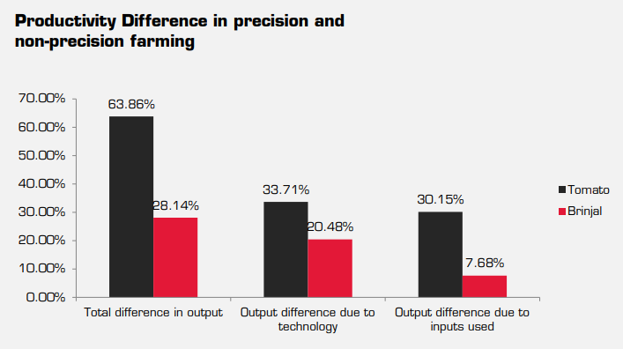

**Fig 3.5.1: Productivity Difference between precision and non-precision farming [25]**

As smart machines and sensors crop up on farms and information develops in amount and range, farming procedures will turn out to be progressively information driven and data enabled. Rapid advances in the Internet of Things and cloud computing are driving the so-called Smart Farming concept (Sundmaeker et al., 2016).[3] While Precision Agriculture is simply considering in-field changeability, Smart Farming goes past that by putting together administration undertakings with respect to area as well as on information, upgraded by setting and circumstance mindfulness, triggered by ongoing occasions (Wolfert et al., 2014).[3] Smart devices expand typical technologies by incorporating autonomous context-awareness by all types of sensors, built-in intelligence, capable of executing or doing autonomous actions remotely.

Big Data technologies play an important, complementary role in this development: devices are fitted with all sorts of sensors that calculate data. This ranges from relatively simple feedback mechanisms (such as a temperature-controlled thermostat) to deep learning algorithms (such as applying the correct plant defense strategy). This is utilized by consolidating with other external Big Data sources, for example, climate or market information or benchmarks with different farms. Big Data and Smart Farming are relatively new phenomena, so it is expected that information about their applications and their research and innovation implications will not be widely disseminated.

3.6 Hardware - Sarthak Agrawal

It is a rising trend across multiple sectors to replace human labor with automation, and agriculture is no exception. Many agriculture elements are particularly labor-intensive, with much of that labor composed of routine and structured tasks — a perfect environment for robotics and automation. Agricultural robots-or AgBots have already begun to appear on farms and perform tasks like planting, watering, harvesting and sorting hence, this concept will ultimately allow more and higher quality of food to be produced using less manual work.

**Driverless Tractors**

The tractor is the cornerstone of the farm, useful in numerous functions according to the farm type and its auxiliary equipment configuration. With advancement in independent driving technology, tractors are expected to be the earliest machines to be converted. Human intervention will still be required in the early stages to set up field and boundary charts, arrange the best field paths using route scheduling tools, decide certain operating conditions and decide certain operating conditions.

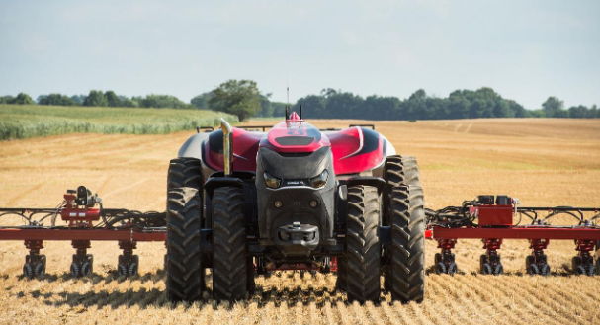

**Fig 3.6.1: Driverless Tractors [16]**

Autonomous tractors incorporated with additional cameras and machine vision systems, GPS for navigation, IoT connectivity and radar and LiDAR for obstacle detection and avoidance, will become more powerful and autonomous thus diminishing the need for humans to manually control these machines.

With farming heading towards the future, current precision seeders accompanied by autonomous tractors and IoT-enabled systems will provide farmers with information.

**Automatic Watering and Irrigation**

Subsurface Drip Irrigation (SDI) is a popular irrigation method that enables farmers to track the amount of water the crops receive. Through integration of SDI systems with the more advanced IoT sensors, the device can independently monitor the moisture levels and track the plant’s health with intervention of farmers only in times of urgency. For example, where previously the farmers had to manually check lines and monitor the pumps, filters and gauges, SDI systems that aren’t exactly robotic, could operate autonomously in a smart farm relying on the data received from sensors deployed across the field.

**Weeding and Crop Maintenance**

Several prototypes including Deepfield Bonirob Robotics, and a UC Davis Smart Farm cultivator prototype have been developed.

The Bonirob robot is about a car’s size and can maneuver autonomously through the field using video, LiDAR and satellite GPS. Robots like this would eliminate the need for humans to manually weed or monitor plants if sophisticated machine learning or artificial intelligence is implemented. In the UC Davis prototype, their grower is positioned at the back of the truck with imaging systems that can recognize the fluorescent color of the seeds when just planted and the farmers can then cut off the weeds that do not light up.

While these prototypes have been designed for weeding, the same base machine can be well-equipped with sensors, cameras and sprayers to detect pests and administer insecticides.

**Harvesting from Field, Tree and Vine**

There are already a wide variety of crop harvesting machines that are ideal for potential automation. Engineers are already at work to develop technologies for delicate harvest work and autonomous traverse across the fields using the right robotic components with a blend of sensors and IoT connectivity, freeing the farmers for other tasks.

One such example of crop harvesting prototype is Panasonic’s tomato-picking robot which includes advanced cameras and simulations to recognize the color, form and shape of the tomato and analyze its maturity if it is ready for harvest or not. Currently, the robot plucks tomatoes by the stem to avoid damage but the future scope involves the robot being capable of gripping the fruit tight enough for harvest but not much that could cause damage.

The vacuum-powered apple picking robot by Abundant Robotics is another prototype for fruit picking which uses computer vision to locate apples and determine its maturity.

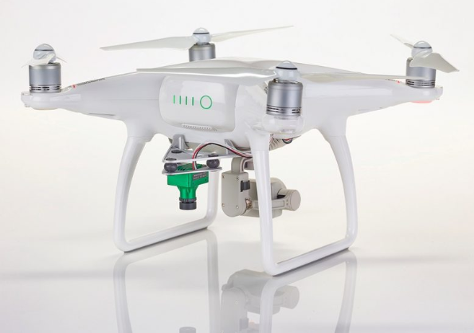

**Fig 3.6.2: Sentera NDVI Drone [21]**

Not only these, but there is a dozen of upcoming robots that are expected to take over the harvesting labor by continuously patrolling fields, monitoring the plants with their sensors and harvesting the ripe ones as and when needed, robust IoT system being the backbone.

**Drones for Imaging, Planting and More**

Where a helicopter or small aircraft pilot is employed to fly over a photographic site, cameras-equipped drones now can generate the same photographs at a fraction of the cost. The cameras used are highly advanced with the capability of infrared, ultraviolet, hyperspectral imaging and record videos as well along with a bonus of increased image resolution. All these imaging abilities help in regularly performing field surveys, drafting a plan for seed planting patterns, irrigation, 2D and 3D location mapping and allows farmers to gather more detailed data using which they can optimize every aspect of land and crop management.

**Planting from the Air**

It isn’t just camera and imaging capabilities that would make a drone useful in smart farming, there are prototype drones being built and tested for their use in planting and spraying. DroneSeed and BioCarbon are examples of companies that are working on drones that can fire tree seeds at appropriate locations. With IoT and software for independent operation combined with GPS, laser measurement and ultrasonic positioning, crop spraying drones can adapt to heights, wind speeds, topography and geography, increasing the chances of faster growth and higher crop yield, thus, automating another labor-intensive task.

Another example of such prototype is Agras MG-1 designed by DJI for agricultural crop spraying with its tank having the capacity of 2.6 gallons (10 liters) of liquid pesticide or fertilizer and a flight range of seven to ten acres per hour. Besides this, it works in co-ordination with other agbots where in cases where a specific crop demands special attention, it could receive a personalized visit from the nearest trouble. Ability to provide individualized attention to any part of the field helps to avoid issues before its occurrence.

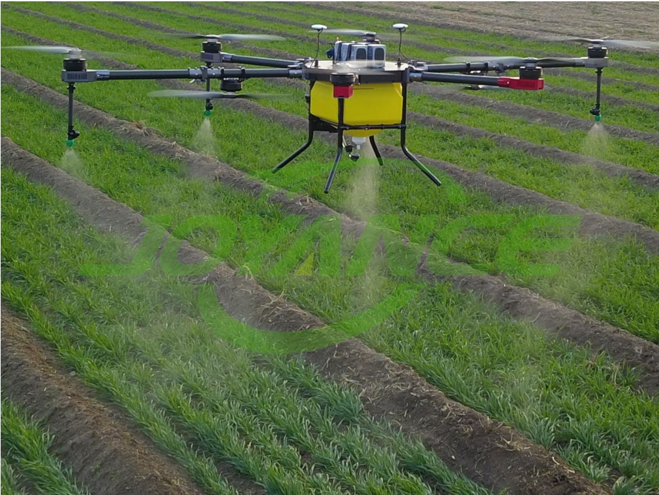

**Fig 3.6.3: Pesticide Spraying Drone JT15L-608[22]**

With various advantages, drones come with few downsides as well. The drones might not be as robust as required and might max out after an hour of flight time before needing to return and recharge.

Given that drones for agricultural use are still early in their evolution, there are a few downsides. Ranges and flight times are not as robust as many farms would need—currently, even the longest running drones max out at around an hour of flight time before needing to return and recharge. Also, the expense for resources is very high, up to $25,000 per drone for anything as highly sophisticated as Precision Hawk Lancaster. There are cheaper models available but the requirement for high technology imagery and spraying techniques may not be delivered.

1. STATUS OF SMART FARMING IN INDIA- Shivani Agrawal

The use of IoT in farming digitization has been included in the Indian government’s draft policy released in 2015. Also, ongoing research in this sector by research and industry organization has contributed to a significant growth in this field. Few of government and private organizations that are working towards smart farming have been listed in the upcoming sections.

1. **OpenCube**

OpenCube is a Bengaluru based organization which focusses on development of IoT-based, farmer friendly device which can perform livestock management, irrigation management, assessment of soil and crop health helping farmers to take appropriate decisions.

1. **AgNext Technologies**

AgNext Technologies is a Punjab based organization which has used IoT, satellite imagery, AI-based image processing and predictive analytics for evaluating presence of pests in larger areas.

1. **Energy Bots Private Limited**

It is Gurugram based organization that has come up with a smart watering system which makes use of GSM and handles or schedules the switching ON and OFF the motor pump through a mobile device.

1. **Tata Kisan Kendra**

This organization uses remote sensing technology with TCL’s extension services to monitor the crop health, analyze the soil and detect any changes in the crop health or pest attack thus predicting the final output.

1. **Government Organization**

ISRO has begun Gramsat project in Orissa which aims at empowering majorly the poor farmers by spreading awareness amongst them and providing access to necessary information and services. A one-way video and two-way audio network is being implemented by NRSA which foresees the yield of mono and multiple crops. ISRO along with other Indian research institutes like M.S. Swaminathan Research Foundation, Chennai, Indian Agricultural Research Institute, New Delhi, and Project Directorate of Cropping Systems Research, Modipuram are working towards smart farming and are expected to turn the green revolution into an evergreen revolution as stated by the Exim Bank officials.

NASSCOM report states that India has around 40 startups dealing with smart farming. But majority of them are research organizations and only a marginal number of solutions provided by them have been actually implemented in the farms. In India, small and medium-sized farmers are the future of Indian agriculture as large farmers constitute 1.5% of the population and contribute only to 35% of the food grain production. Thus, it is necessary for these research and development organizations to understand the requirements of small and medium sized farms so that it is easier for them to adopt innovations and techniques and increase the agricultural yield. The small and medium farmers produce for their families and a small portion is left for the market, giving farmers a small value for their products. Thus, introducing smart farming technologies should primarily aim at promising lower costs of production and guide them to get better value for their products.

1. BENEFITS OF IOT IN AGRICULTURE- Shivani Agrawal

Using the Internet of Things in agriculture provides previously unseen productivity, asset and cost reduction, optimization and statistics-driven processes, as in other industries. However, in agriculture, these benefits do not act as improvements, but rather as solutions to a range of hazardous challenges plaguing the entire economy.

1. **Efficiency**

In today’s race, farms must constantly focus on increasing the production in challenges like deteriorating soil, reducing land quality and rising weather uncertainties. IoT enabled farming enables farmers for real-time tracking of crops and conditions. They get quick insights, can foresee issues before they unfold and make rational choices on how to dodge them. Moreover, IoT applications also incorporate robotics to farming, such as market-based irrigation, fertilization and robot harvesting.

1. **Expansion**

By the time the population reaches 9 billion, 70% of them will live in urban environments.[1] IoT based greenhouses and hydroponic frameworks empower brief and nourished food supply chain and ought to be able to provide these individuals with fresh natural products and veggies. Smart closed-cycle farming systems permit producing food fundamentally everywhere- in grocery stores, on skyscrapers’ walls and parapets, in cargo containers and, of course, within the convenience of everyone’s home.

1. **Reduced resources**

Plenty of IoT solutions concentrate on optimized utilization of resources like water, power and property. Precision agriculture using IoT depends on data from various field sensors which help farmers efficiently distribute just about enough resources to one crop.

1. **Cleaner process**

IoT based precision farming system not only allows farmers to save water and energy rendering greener farming but also significantly reduces the use of pesticides and fertilizers. Compared to the traditional farming methods, this approach makes it possible to achieve an organically cleaner product.

1. **Agility**

Using IoT in agriculture increases the agility of the process. Utilizing real time systems for monitoring and forecasting, farmers can quickly respond to significant changes in weather or health of the crops making it easier to manage the health of the crops and save them in extreme weather conditions. Also, it enables them to avoid any mishaps before its occurrence.

1. **Improved product quality**

Data-driven farming contributes in better farming and growing better products. Using sensors, aerial drones and farm mapping technologies, farmers better understand comprehensive connections between the conditions and the health of the crops. The best conditions can be replicated, and the nutritional value of the crops can be increased by utilizing the interconnected devices.

1. CONCLUSION- Shivani Agrawal

As already mentioned, smart farming can be considered as a successful approach only if it is implemented in smaller and lesser arable farms along with the larger fields turning digital farming into reality and reaping the benefits of IoT like improving the production of the crops, save resources like water and electricity and economically efficient crops that need less efforts but yield more profit. India’s agricultural sector needs to be restored and the purchasing power of the marginalized and the poor population needs to be strengthened to boost the overall economic development. This can be achieved only if the key areas of concern and the programs planned and implemented to overcome it are incorporated under one system. IoT can be best described as an infrastructure that merges issue-specific technologies of different domains. With 70% of the Indian population dependent on agriculture, India’s farming scenario is the best area of applicability of smart farming technologies. Besides the usual agricultural work, the set of technologies used for smart farming can be applied in other areas like livestock monitoring, fleet management, indoor farming, fish farming, forestry or storage monitoring. A beneficial and socially acceptable farming system can be built with a combination of ICT and data management. Also, development of legislature policies encouraging the necessary legal and business infrastructure for smart farming, carefully considering the perceptions of the supporters and the critics as well as finding appropriate answers to the emerging ethical issues aids in the accomplishment of the goals.

REFERENCES

1. Srilakshmi A, Rakkini J, Sekar KR, Manikandan R. A Comparative Study on Internet of Things (IoT) and its Applications in Smart Agriculture. Pharmacognosy Journal. 2018;10(2):260-264. doi:10.5530/pj.2018.2.46.

2. Keswani B, Mohapatra AG, Mohanty A, et al. Adapting weather conditions based IoT enabled smart irrigation technique in precision agriculture mechanisms. Neural Computing & Applications. 2019;31(1):277-292. doi:10.1007/s00521-018-3737-1.

3. Muangprathub J, Boonnam N, Kajornkasirat S, Lekbangpong N, Wanichsombat A, Nillaor P. IoT and agriculture data analysis for smart farm. Computers & Electronics in Agriculture. 2019;156:467-474. doi:10.1016/j.compag.2018.12.011.

4. Bachuwar VD, Shligram AD, Deshmukh LP. Monitoring the Soil Parameters using IoT and Android Based Application for Smart Agriculture. AIP Conference Proceedings. 2018;1989(1):1-8. doi:10.1063/1.5047679.

5. Kulothungan S, Kamalakannan K, Thirugnanam P. Agriculture Robot for Irrigation and Automation. Bulletin of Pure & Applied Sciences-Geology. 2018;37F(1):110-115. doi:10.5958/2320-3234.2018.00010.0.

6. Mekala MS, Viswanathan P. CLAY-MIST: IoT-cloud enabled CMM index for smart agriculture monitoring system. Measurement (02632241). 2019;134:236-244. doi:10.1016/j.measurement.2018.10.072.

7. Shafi U, Mumtaz R, García-Nieto J, Hassan SA, Zaidi SAR, Iqbal N. Precision Agriculture Techniques and Practices: From Considerations to Applications. Sensors (14248220). 2019;19(17):3796. doi:10.3390/s19173796.

8. Khanna A, Kaur S. Evolution of Internet of Things (IoT) and its significant impact in the field of Precision Agriculture. Computers & Electronics in Agriculture. 2019;157:218-231. doi:10.1016/j.compag.2018.12.039.

9. Al-Fuqaha, A., Guizani, M., Mohammadi, M., Aledhari, M., & Ayyash, M. (2015). Internet of things: a survey on enabling technologies, protocols, and applications. IEEE Communications Surveys and Tutorials, 17(4), 2347–2376.

10. Aqeel-Ur-Rehman, A. Z. A., Islam, N., & Shaikh, Z. A. (2014). A review of wireless sensors and networks’ applications in agriculture. Computer Standards and Interfaces.

11. Wolfert, S., Ge, L., Verdouw, C., & Bogaardt, M.-J. (2017). Big data in smart farming—A review. Agricultural Systems, 153(May), 69–80.

12. Jayaraman PP, Yavari A, Georgakopoulos D, Morshed A, Zaslavsky A. Internet of Things Platform for Smart Farming: Experiences and Lessons Learnt. Sensors (14248220). 2016;16(11):1884. doi:10.3390/s16111884.

13. Stočes M, Vaněk J, Masner J, Pavlík J. Internet of Things (IoT) in Agriculture - Selected Aspects. Agris On-Line Papers in Economics & Informatics. 2016;8(1):83-88. doi:10.7160/aol.2016.080108.

14. Ravi, N. and Jagadeesha, C.J., 2002, Precision Agriculture, Training course on Remote Sensing and GIS Applications in Agriculture, May 27th –7th June, 2002, RRSSC- Bangalore, pp: 225-228.

15. U.K. Shanwad, V.C. Patil, G. S. Dasog, C.P. Mansur and K. C. Shashidhar (2002) Global Positioning System (GPS) in Precision Agriculture The Asian GPS Conference 2002, (October 24 – 25, 2002, New Delhi, India)

16.<https://www.jsonline.com/story/money/business/2016/10/18/case-ih-developing-driverless-tractors/92355244/>

17.<https://www.scoop.it/topic/uav-operator/p/4076064043/2017/03/04/drone-crop-mapping-services-and-systems-from-drone-ag>

18. <http://www.emfexplained.info/?ID=25916>

19.<https://medium.com/sciforce/smart-farming-or-the-future-of-agriculture-359f0089df69>

20.<https://www.photonics.com/Articles/Optical_Sensors_Advancing_Precision_in/a61986>

21.<https://bestdroneforthejob.com/drone-buying-guides/agriculture-drone-buyers-guide/>

22.<http://www.wecanie.com/html/sprayer/products/15L_precision_agriculture_pesticide_spra.html>

23.<https://www.geospatialworld.net/article/precision-farming-in-indian-agricultural-scenario/>

24. Abhishek Beriya and V. N. Saroja, May 2019, Data Driven Decision-Making for Smart Agriculture, CSD Working Paper Series: Towards a New Indian Model of Information and Communications Technology-Led Growth and Development

25. TechMahindra: Precision Agriculture and Potential Market in India- Research Insights.<https://www.techmahindra.com/sites/ResourceCenter>

26. <http://www.ifpri.org/blog/five-ways-reduce-farm-distress-india>

APPENDIX

